Items use by one child
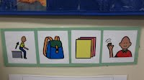
This visual strip is used to assist a child to stand up, get backpack, get papers, wave good-bye. This would be a visual of what things a child would do at the end of the day, before getting ready to leave.
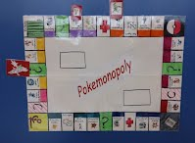
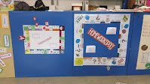
The game idea grew out of the game that was already being used in the classroom by Kara Wigger. Her Student designed the Pokemonopoly out of his love of Pokemon. Together they were able to create a game that he loves to play and finds very reinforcing. Therefore this game is helping him to stay on task, complete work quickly, has eliminated his negative behaviors and is helping with reading, independence and his own confidence. (this game could easily be played by more than one student by just adding another character (player).
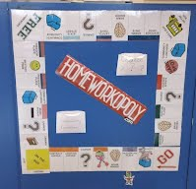
Here is another idea of using a game to motivate a student.
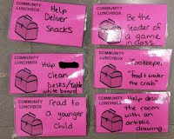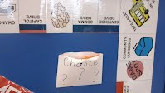
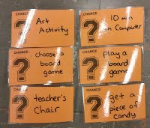
Look how creative this teacher and child were
to even make cards that will help build social
and individual skills!
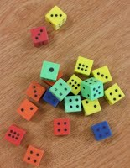
The child earns a die when his work is complete.
This allows him to go and play the Pokemonopoly!

